|  |
| --- |
|  |
| **HEALTHCA** |

**Background of Healthca**

The paper is prepared for a project. And our project is to build a software called "Healthca". Healthca is a health care center which is used by 4th revolutionary technology. Our main purpose is to solve some serious problems of our country. Every day we see a lot of people having problems detecting their disease and that's why we build an AI assistant. Also, there are so many people having problems knowing all the current news and all the disease’s information and for that reason, we build some great features for all people. Now for description, we described all the problems, solutions, and how we will manage all the things, the design, the testing, and also the business analysis, so that you can see and know all the things.

Basically, we prepared this paper or this project for our course which is CSE 136 or the Software project course and we are going to submit this paper to our honorable teacher or instructor Ms. Nusrat Jahan, who taught us and inspires us to do this project. She taught us all the basic things and how can we build a project.

Now we know this project is for a course and this project is a part of our study. But our main purpose was to build a project using 4th revolutionary technology. Because we all know how important the 4th revolutionary technology and the 4th industrial revolution.

We know the Fourth Industrial Revolution is a way of describing the blurring of boundaries between the physical, digital, and biological worlds. It's a fusion of advances in artificial intelligence (AI), robotics, the Internet of Things (IoT), 3D printing, genetic engineering, quantum computing, and other technologies. And we know the coming world is going to be a 4th industrial revolution based world and almost some countries already using the 4th revolutionary technology including Bangladesh. So all the 4th revolutionary technology is important for our future and our main feature or the AI is also a 4th revolutionary technology.

* **Supervisor name:**

Nusrat Jahan

Adjunct Faculty, DIU

Managing Director

Interactive Artifact Ltd.

* **Team members:**
* Md. Al-Amin (202-15-3799)
* Md. Shakil Rana (202-15-3816)
* Tasnim Jahan Tonni (202-15-3789)
* Raisul Islam (202-15-3797)
* Gazi Adnan (202-15-3796)
* Shyeam Ahmed (202-15-3795)
* Tanvir Mahtab Tapu (202-15-3800)

**Table of Contents**

Introduction............................................................................................................. p. 5

1. Problem Definition.......................................................................................... p. 4
2. Proposed Solution..................................................................................... p. 5 – 8
3. Main Body................................................................................................. p. 5 – 8
   1. Reflection of SDLC............................................................................. p. 9 - 15
      1. *Planning*
      2. *Requirement analysis*
      3. *Design*
      4. *Development*
      5. *Testing*
      6. *Lunching*
   2. Business Analysis.............................................................................. p. 9 - 15
      1. *Strategic Business Analysis*
      2. *Market Analysis*
      3. *Business Case Analysis: Financial Aspects (Hypothetical)*
4. ANNEXURES.............................................................................................. p. 5 – 8
5. Conclusion................................................................................................ p. 5 – 8
6. References................................................................................................ p. 5 – 8

# **Introduction**

Our idea is to build an easy and helpful health care center. In our country, most of the time we hear that a lot of people led their life with big disease but detect after a long time. And a lot of people in our country usually don't care about their disease and they take medicine at their own thought, for this reason in future they face some big problem.

Also sometimes we hear a lot of people detect the wrong disease from some undergraduate doctor or some random people and they believe them and take medicine from them but for this reason, they face big problems in their life because of taking the wrong medicine. For these serious problems, we find out some great solution to solve these. So that we build a team and our goal is to build software that can solve these problems. We decided on our software name and that is "Healthca".

In our app "Healthca" there is a unique and most important feature is that you can tell our AI assistant your symptoms and it will find the disease that matches with your symptoms and give you the percentage. And after seeing your percentage(Percentage thing- if you said your assistant that you have tiredness, cough, snivel, and your assistant give you about 90 percent of chance that you have a fever then you can believe that you have a fever but it doesn't mean that you have really a fever, there are also a doctor option and you can see the right doctor and then you will be good ) and also you can see the primary treatment or you can book a doctor regarding your symptoms which is nearby your location. For booking a doctor, you just have to go to the doctor section and turn on your GPS and then the AI will automatically find the doctor which is nearby your location. Also in this app, there is going to be a useful feature and that is Health news, you can see all the current health news and can aware of yourself. Also, there is another feature called Condition library, in the condition library, you can see the most read articles by users you can also get to know about some disease and their risks, symptoms, primary treatment, etc. and this can also help you to update yourself and also you can aware yourself. And it's going to be a very easy UI so that every single person can use it very easily.

Now I just want to tell you that this app is going to be for those who want to detect their disease, who want to aware for good health, who want to always update themselves about health. Because this is very important, we all should take care of ourselves and know all the things about our health and should lead a healthy life.

And that's why we as a team or the "Healthca" proudly say to all the people that we can help you to organize your health.

## Problem Definition

When we decided to go with this project or the "Healthca" or the app which is based on a health care system, firstly we thought about the current situation of the health sector in Bangladesh, although our app is going to be for all the national and international peoples. But we were constantly researched about the health sector of Bangladesh because first of all, we want to help our countries people and then the others. Then we find out some serious problems and challenges of Health sector in Bangladesh and those problems are serious and then we all should aware and also find out the solution otherwise we will face some serious and huge problems in future and we will lose so many lives.

So I want to discuss some of those problems:

1. Nowadays almost all people suffer from more or fewer diseases. Some are big diseases and some are small ones. Some people do not take minor illnesses very seriously, they think that this will get better and most of them led their life with these diseases’ but detect after a long time. As a result, they detect with some death taking big disease and so many people lost their lives because of this problem. Again, many small diseases can turn into big diseases. It can also cause human death.
2. Also in our country, there are so many people, who cannot go to the doctor always due to money crisis. We see so many people led their life with some minor or major health problems, but for detecting disease, you have to go to the hospital and then you have to go to the doctor and usually the doctor detect the disease or they just throw some tests to you to detect the disease. And we know, for doing these things you have to pay lots of money because the doctors and the hospital charge a lot of money and that's why they usually don't want to go to the hospital and led their life with their health problems. Again this is one of the common and big problems for all the people but most importantly this is the biggest problem of every poor's and the middle-class people.
3. Also in our country, many people are indifferent to their health care and don't care about any disease. If they have any disease, they take the medicine of their choice without checking it. That's not right, because there may be many diseases with the same symptoms. In that case, the real disease is not caught by us. As a result, the disease can settle in the body day after day. The latter is what makes people suffer and is threatened and also so many people lost their lives just because of this childlike behavior.
4. In our country, just to save some money, many of us went to unregistered doctors or undergraduate doctors to detect the disease or prevent the disease and also most of the people in the countryside have a deep faith in the treatment of fake doctors, which is really a serious problem because the undergraduate doctors don't even know how to cure or detect a disease correctly, they are just going to throw some random medicine to you and pay some money for it and we also see the people believed them and take medicine from them which is a bad thing for us. Those medicine or drugs can have a bad effect on our body.
5. Sometimes we see a lot of people having problem to find out the doctors for their disease. And it's one of the common problem of our countries people. Some people know which doctor should they go but most of the people don't and they just run hospitals to hospitals to find out the best doctor for their disease or some of them just give up and went to a random doctor. So we have to fix this problem as soon as possible.
6. We see a lot of people don't have the basic knowledge of some common diseases. We all should know some of the basic knowledge like the symptoms, the risks, the primary treatment's, etc. of some common disease’s because at the end of the day, we all have to take care of our health in any situation and in this current world, a lot of diseases born every day. So we should see the current health news every day and know some basic knowledge about some common diseases.

We discussed some of the serious problems of our country but there is a ton of more problems or challenges of our health sector in our country. But currently, we are working with these problems and we find out some great solution and want to fix these problems as soon as possible. And in the next section, you can see all the solutions.

1. **Proposed Solution**
2. **Ai assistant:** We know a virtual assistant or the AI is a software agent that can perform tasks or services for an individual based on commands or questions. It can access information from a variety of online sources. Ai assistant can perform various types of tasks based on the user need and command, which can automatically perform management or data handling tasks based on online information without user initiation or interaction. Now I talk about our app’s Ai assistant. Our app mainly depends on our AI assistant because there will be thousands of people active in our app, taking our facility so AI assistant will greatly help us to co-up with our users. AI assistant will guide people in every sector of our app such as one user describe his symptoms and the AI will give him feedback basis on our app data. On the other hand, our Ai will also suggest to our client about the nearest doctor, clinic, or hospital. It’s like a helping hand to our app. It’s like a friend to our app a friend who will be with us 24/7.
3. **Finding doctors:** With the help of our Ai and GPS, our customers can find the best doctor in his area to cure their diseases and solve their all health problems. Finding the best doctor which is nearby your location and based on your disease, which is really hard to do in manual, for this reason, we developed an AI assistant. In the app, you just have to open the GPS on your device, the AI assistant will automatically find the doctors based on your disease, which is nearby your location and you can choose which doctor you want to see, which is really helpful. Also in the app, you can book an appointment with your doctor. But for book an appointment for a doctor, you can book it online or the app is going to give you the number to book your doctor, another helpful feature. And for your kind information, the app will always find you the doctor from a respectful hospital, not the undergraduate or unregistered doctor, which is really important for any person. And I'm sure these features can help a lot of people in our country and these features will make a bridge between patient and doctor through an app or software. And it's only possible because of our AI system which is a 4th revolutionary technology.
4. **Current health news:** Our app or "Healthca" is not only a detecting disease app but also a knowledge gathering app for our customers. People all over the world do not properly aware of many diseases, which can be a serious problem for human life because before curing the disease, we have to know the best information and awareness about the disease. In this current world, many diseases have no cure, so we should aware of those diseases and keep a safe distance from those diseases’. In the current world one disease called "Covid-19" causing so many deaths. Our world begins to shut down in 2019 to now for this disease. But we see so many peoples are not aware about this problem. They do not know how this disease spread, what problem it causes and how can we defend the problem. So eventually health news is very important for us. In our app, we provide a "Health News" section, where we will provide regular and true news about health to all our customers. Not only “Covid-19” and the common diseases, but we will also provide all the disease’s news and in the headline, we will always provide the diseases which recently discovered and threaten our world. From this feature, we all can know all the current news about health and take care of ourselves, which is really helpful for us.
5. **Condition library:** In "Healthca" or our app, Condition Library is a new and unique feature that is really a helpful feature for all of us. From this section, we can know some very important information about any diseases and many more things. They are:

* In this section, there will be some articles about various diseases. There will be some most common diseases name and also other diseases. In the article of any disease, you can know most of the information about that disease, like the Risks, Symptoms, Primary treatment, Prevention, etc. many more things. From this amazing feature, we all can know all the information about any disease, which is really important and helpful. Because most of the people in our country don't know much about any diseases and that's why they usually don't care about any disease. So that we build this feature to know basic knowledge about any disease.
* Also in this section, there is another feature is that you can see the most read articles by users and also you can see your last read article, which is really helpful because we all lead a very busy life, sometimes we don't get much time to read all the articles so that we build this feature and for this feature, you just have to go to the condition library and you can see the most read articles and you can read those articles in your busy time.

So in this section, we discussed some of the solutions and the features of our app, or "Healthca". While using this app, all the people can detect their disease, find out the doctors nearby their location, see all the current health news and last but not the least, know all the basic information about any diseases. And all these features will have fixed all the problems we've discussed in our problem section.

## Main Body

### Reflection of SDLC

#### Planning

Our app or "Healthca" is going to be used for those who want to take care of their health, for those who want to detect their disease easily, and for those who want to know all the basic information about any disease. In our app, the functional things like the disease detector, finding doctor, the news, and the condition library will be in this app and every user can find these things very easily. Every feature has its own section, and every section is going to be easy to find. This project or the app is going to be managed by the AI System and it's a 4th revolutionary technology.

And in this planning section, we will show the GAANT Chart, where you can see a bar chart that illustrates our project schedule. We will also show you the WBS or the Work Breakdown Structure where you can see all the work of our project in sequence. And lastly, we will show the RACI matrix, where you can see the responsibility assignment of our project, the tasks, the milestone, the key decision. Most importantly, you can see every team member's work.

**Gantt chart**

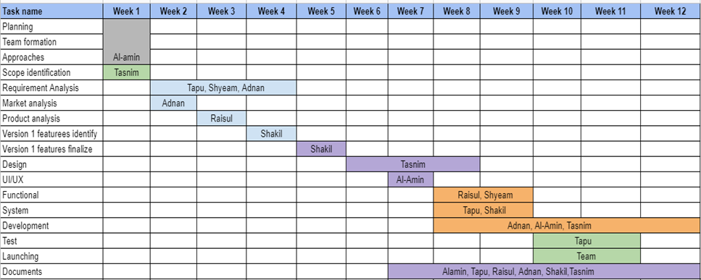

**WBS**

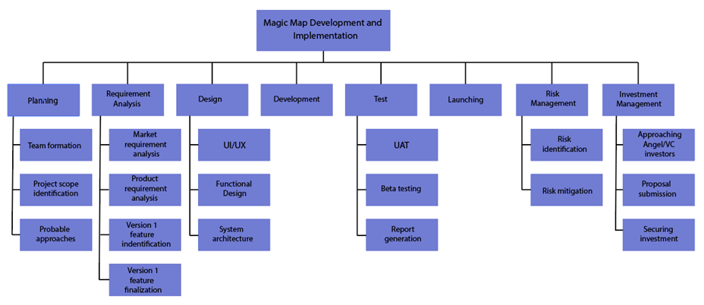

**RACI Matrix**

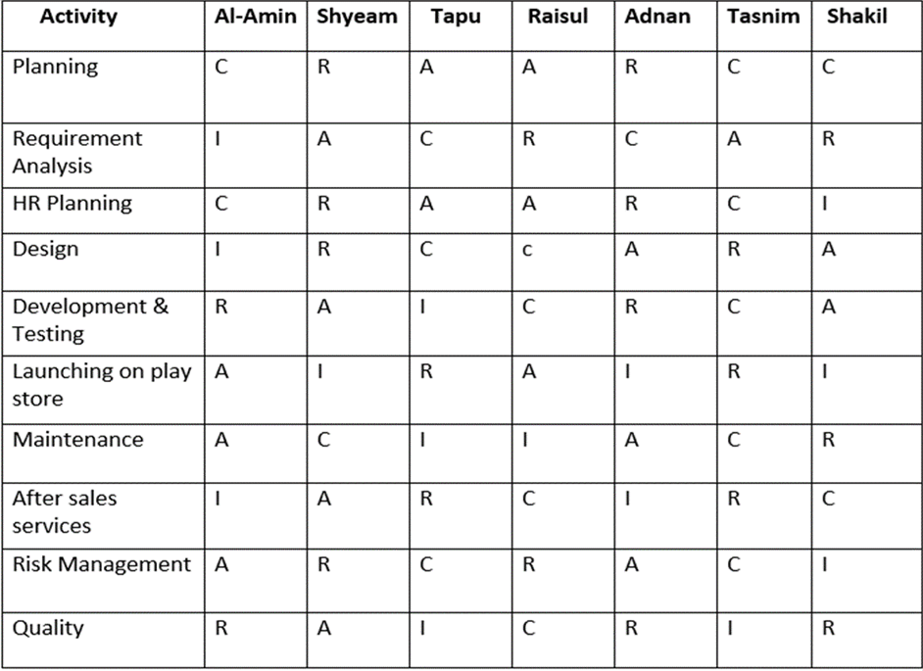

#### Requirement analysis

Here is the SRS or the Software Requirement’s Specification, where we discussed all the requirements of our Software:

1. **Introduction**

SRS means Software Requirements Specifications, which is a document that describes what the software will do and how it will be expected to perform. An SRS is a framework that every team will follow to involve in software development. Using the SRS helps to ensure requirements are fulfilled providing critical information to multiple teams.

1. **Purpose:**

The purpose of our software is to care about our health. Healthca is an overall health care app that will give us which disease it detects and a general description of our health condition. It's an app for those who want to know which disease they detect and for those who want to know their health condition and want to touch with the doctor or the health instructor. This app also includes the health news which helps all the customer/user to know all the current health news. Also, this app includes one unique feature and that is the condition library which helps all the customers/users to know all the descriptions about all the common diseases. Finally, we can tell that this app is a health care center or a disease detector with some great health care features which helps all the people to know about their body and take care of their health. In a current world, we see a lot of people don't take care of their health, some of them don't even detect their disease for a long time and then after some years, they get infected with many big diseases. So we all should take care of our health every time so that we can live happily.

And we as a team or the "Healthca" proudly say to all the people that we can help you to organize your health.

1. **Document Conventions:**

In this project we have used the Calibri font We have followed the standard of our supervisors project paper In this project we have used lots of features of MS word like insertion of picture, table, font color, alignment is used in systematic way and it has an complete order, and so many cool tools are used in this project.

1. **Intended Audience and Reading Suggestions:**

The document is intended for requirements engineers, developers, project managers, marketing staff, users, testers, and documentation writers. Also, this project can be a prototype for any health care app developers so this paper can be shown to them also because we want to build more and more health care software so that anyone can take care of their health and it's our responsibility.

And those who want to know all the information about this app, it is highly recommended to read this paper because we input all of the main or basic information about the app in this paper. For reading this paper we can suggest you to read this paper from the cover page and then the introduction and the rest.

1. **Project Scope:**

Project scope is the part of project planning that involves so many things from the project and it includes the project goals, the benefits, long-term plan, and many more. Here we discuss those things, such as:

1) Benefits: We the "Healthca" app is a health care center for all the people who want to take care of themselves. After using this app you can be benefitted in many ways, like

• You can detect your disease and after detecting you can see all the information about the disease and also AI will suggest you the doctors for that disease, from your area

• You can see all the current health news and updated yourself with this changing world.

• You can see the condition library and know all the basic information about any disease and protect yourself.

2) Goals: The Healthca app is a modern app that will manage by the 4th revolutionary technology. We will use all the modern technology to give you a great service. But we also have some goals for the future and after launching, we are going to work for it. Such as,

• We want to raise the number of features.

• We want to connect with more hospitals and doctors with us to give you a better service.

• Also we want to connect with the countries government to work with them and help all the people very easily.

3) Objectives: We want to build an app that helps all people to take care of their health and also organize themselves.

1. **Overall Description**
2. **Product Perspective:**

We know this project comes from a problem which is very common to us and the problem is that in our country, most of the time we hear that a lot of people led their life with the big disease but detect after a long time and also many people usually don't care about their disease and they take medicine at their own thought. Also, we see a lot of people detect the wrong disease from some undergraduate doctor or some random people and they believe them and take medicine from them. These are some common problems which we all know but we don't usually care about them. So basically this project comes from those problems and we as a team or "Healthca" are going to work for it.

Also, we didn't see any of the companies working on this idea.

1. **Product features:**

* In this app, you can write down or speak to your assistant about your symptoms and artificially it will detect every disease that matches with your symptoms and it is going to give you some medical advice that can help you for some time.
* You can see every doctor’s information or test information and know which doctor is going to perfect for those symptoms. After that you can also book an appointment for you or for the patient.
* You can input your previous records, like if you are a smoker you can input that, also if you had high blood pressure, diabetes, heart problems, allergic problems, fever etc. you can give those feedbacks.
* In this app, you can see all the current news about health.
* There is a condition library that has a unique feature like you can see the most read articles by users you can also get to know about some disease. You can also see your last read article.

1. **User classes and characteristics:**

We know a “customer” is essentially the purchaser. They are the one giving us money. A “user” is the person actually using the software or product we're designing. In this section, we are going to talk about the users and their classes.

**Frequency of use**: The users are going to use this app only when they feel unhealthy, or find some symptoms for a disease in their body. Even though if they feel any abnormality in their body they can talk to our AI based software.

**Subset of product function used:**

* First of all if any users feel unhealthy, they are going to use only the 'disease tracker' option.
* If the users want to know some health information or current news, they have to use the 'news' option.
* If the users want to know some information about any specific disease like their risks, symptoms, treatment etc. They have to use the 'Condition library'.

**Technical expertise:** Users have to know at least some basic knowledge about how to use any app or software and also they have to know how to input information to any app.

**Privilege levels:** Our app or "Healthca" is a health care center. This app is for those people who want to take care of their health, who want to detect their disease easily. So these people will register our app and the limitation of users/customers are not limited, it's going to be unlimited for now but in future, if we want to limit our users/customers, we will do it. Our database administrator is going to be our team leader, MD Al Amin and he is going to organize data and he is going to make sure that data are available to users and secure from unauthorized access.

**Educational levels:** There is no specific such things like everyone needs to be educate and they should have the Basic English knowledge. And we think that’s more than enough for get used to with our software.

**Experience:** There is no specific or hard things in this app. This is going to be a very easy app. But every user should experience at least some apps that has an easy UI and they should just have the knowledge of inputting information in software.

1. **Operating Environment:**

This app or "Healthca" is supported for all windows, IOS and android devices. Those who use these operators, can use this app "Healthca". Also the UI is going to basically same for all this operator but for each and every operator there will be some changes. It's just some UI change that shouldn't bother your while using the app. If you are a both IOS and android user, you won't have problems for this UI changes.

1. **Design and Implementation Constraints:**

Our software's design has been developed by Tasnim Jahan Tonni(Adobe), Md Al Amin (Paper prototype) and Shyeam Ahmed(Adobe). They have faced many problems while doing this design.

Shyeam says when he first makes a layout of our app with the help of Adobe XD, he faced the color problem like what color to choose and what color should be suitable for our app. Again when he thought about the UI design, he faced another problem, like what image should be fit for our app, where should be the color being deep and which box have a border or shadow. That is how he faced problem while doing the design.

1. **User documentation:**

1) **User manuals:** When you buy or install the app from particular store like play store, app store etc. any store, there is going to be a short and simple user manual like how you can use the app, or how you can input any information of yours.

2) **Online help:** In this app, there is going to be a help section where you can ask any of your questions to our AI assistant and they will answer your all questions and you can use the app very easily.

3) **Tutorials:** In every particular store which support IOS, android and windows, there is going to be a tutorial video and in the video you can see how to use the app like how to detect your disease, how to see the results, the news and also the condition library. Basically you can see all the things to use the app easily and it can help you out.

1. **System Features**

**USE CASE ANALYSIS**

|  |  |  |
| --- | --- | --- |
| **Product’s feature**  **(external/overall features/activities)** | **Functional Features of system** | **Priority** |
| **Healthca:**  Disease identification | * System should identify the diseases based on symptoms * System should respond when users enters the symptoms of disease | High |
| Finding Doctor | * System should find out doctor for the particular disease * System GPS technology has to work properly for finding doctor | High |
| Providing health news | * System should provide regular news about any disease | Medium |
| Condition library | * System should show the most read health articles, last read articles. * System should provide some common disease details | Medium |
| AI support | * System should interact properly to the user while telling about symptoms | High |

1. **External Interface Requirements**
2. **User Interfaces**

"Healthca" or our app is a health related software which provides information about the various diseases on the basis of symptoms and reports. The user interface is very simple and easy to use. One of the specific guideline is every user should connect to the internet while using the disease tracker because disease tracker is controlling by the AI assistant, so internet connection is must. Also if you want to use the news and condition library, also every user will need internet connection. But every user can see their downloaded reports without the Internet connection.

1. **Hardware Interfaces**

Healthca is an improved differential disease detector application, built for Android, OS and windows. It is a database driven application, which contains a lot of searchable data for many diseases. The database contains a lot of information related to each treatment condition and their symptoms. Users can use this application to search for brief information about diseases and create a list of possible diseases.

1. **Software Interfaces**

Software interfaces: "Healthca" is an app that's going to support in android, OS and windows. Also in this software there is a lot to store, manage and change information. In this software, every user has to input their information like their email, name, also some personal data to login. Also every user has to input their health condition and their previous health records.

1. **Communications Interfaces**

In this project we are decided to build an app and its name is “Healthca". So Healthca is an app that's going to be available in various app stores and app stores should support Android, OS and Windows only. Now it's not going to available as a website in various web browsers, but if we see that our app is capable for a website, and all the work in app is capable in a website, then we will be creating a website for this app and we will maintain both the app and website and it’s going to be support in all the safe web browsers like Google Chrome, Microsoft web browsers, Opera mini etc.

1. **Other Nonfunctional Requirements**
   * + 1. **Performance Requirements**

"Healthca" is a health care based app. And for sure Its service will be like a normal health based app. But we can ensure that it's going to be a very easy to use and its service will be very good and correct. But in some situations the app will perform differently,

Like:

1) While updating the app, the app's going to be off for sometimes for update.

2) If you use this software in a less ram device, the app is going to be slow.

3) If your device has virus, the app may hang for sometimes.

4) While giving your information in the app, you have to be very careful because if you give wrong information or half information, the app is going to give you the wrong report, so you have to be very careful.

5) For install or buy this app, you have to have iOS, android or Window device, other than that, you won't be able to download this app.

* + - 1. **Safety Requirements**

"Healthca" is going to be a software and all the software have some security requirements. For this app you have to maintain some things like:

1) While using this app, you should connect to the internet connection. You can only see the downloaded report in offline.

2) For using this app, you must have android, iOS or Window device because this app only supported to this operator.

3) If you want to see the exact report or the exact disease you have, you must have to give the right information about you, if you don't, app is going to give you the wrong report.

4) For using this app very easily, you may see the tutorials on the app stores, it may help you.

* + - 1. **Software Quality Attributes**

• Our software is a health care center and our app is designed like a health care center. After using this app, anyone can easily tell that the app is particularly for health related. So the quality is good enough for any users.

• Also our app is very user friendliness. The app is designed very well and anyone can use the app easily.

• The app is very useful for those people who want to take care of their health and detect their disease easily.

#### Design

**Paper prototype**

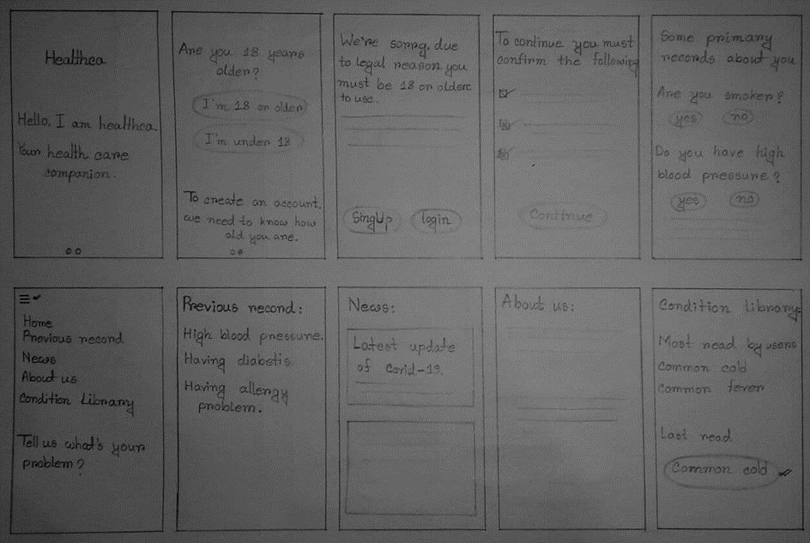

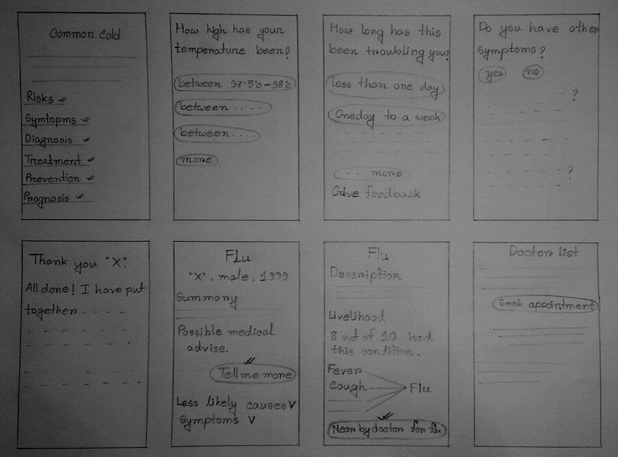

**Adobe XD**

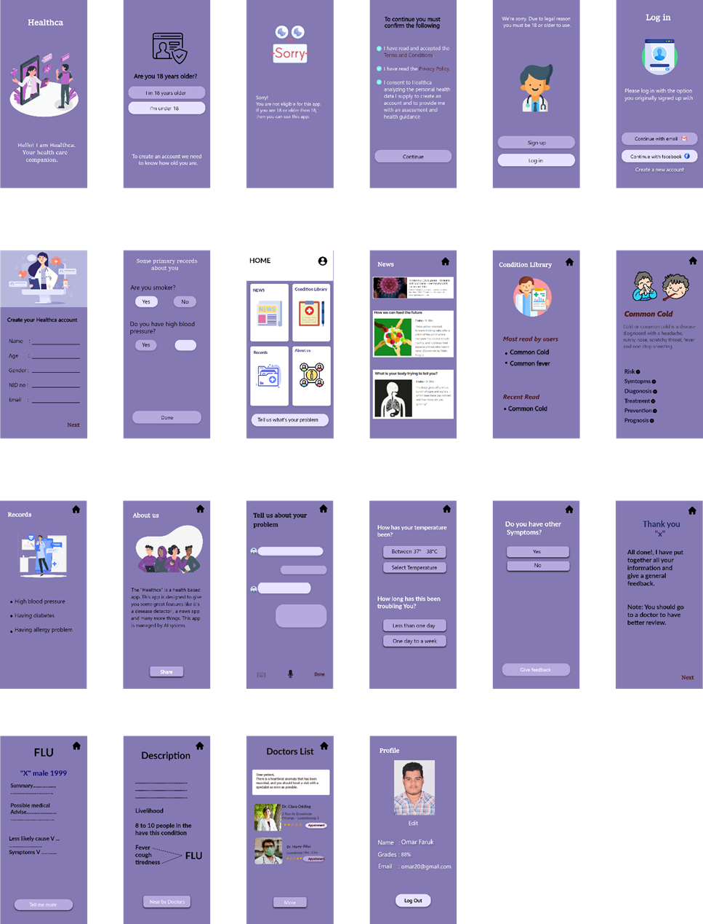

#### Development

In our project we are going to use the python programming language for our AI based apps.

Because python is a widely used best language for AI programming due to its ease of programming. Python is a high-level programming language. More standard libraries are available in Python than other languages. It takes less development time compared to other languages.

Python is also a general-purpose programming language that can be used on any modern computer operating system. It can be used for processing text, numbers, images, and scientific data and just about anything else you might save on a computer. It is used daily in the operations of the Google search engine, the video-sharing website YouTube, NASA and the New York Stock Exchange. These are but a few of the places where Python plays important roles in the success of the business, government, and non-profit organizations; there are many others.

#### Testing

**Q/A testing:**

Our app is user-centric and easy to work with. We can easily diagnose the disease in this app. With the help of Ai, there is an advantage to tell the patient's symptoms through voice command. There is a conditional library for accurate diagnosis. Through this, some of the symptoms of the disease will be determined in advance. Due to which the disease can be easily diagnosed accurately. After filling up all the conditions, the name of the disease will be displayed depending on the patient's symptoms. Depending on the disease, the doctor's list is applicable for that disease. And every customer and users information in our app will be kept through high security.

We promised to make sure maximum quality of our product.

#### Lunching

After finishing our all paper work and budgeting we are going to launch our product in few months. But before launching our product we have to do more things regarding to launch our product like we have to know more of our customers or the users. Also we have to write a positioning statement, a positioning statement is an expression of how a given product, service or brand fills a particular consumer need in a way that its competitors don't. Then we have to plan our marketing strategy, set a goal for launching. Also for more marketing, we can create a promotional content for every social media or show our product in a campaign. After doing all these things we will be able to launch our products.

### Business Analysis

We have done a business analysis. This analysis can be changed in future but for now, this is our first business analysis. And we are going to show the financial part of our business. In our analysis you can see that we have done a calculation of net cash flow, identifying the payback period, net present value, internal rate of return of the project.

1. ***Five-years Projection***

A detailed five-year projection of this project has been done by us. You can see that, the detailed total expense in Annex 1, revenue in Annex 3 and cash flows in Annex 2. We have done this calculation very carefully with the sense of current market value and customers. In the cash flow, it's assumed that the cost will be increased by 25% every year which has been predicted based on the current market value and other companies also.

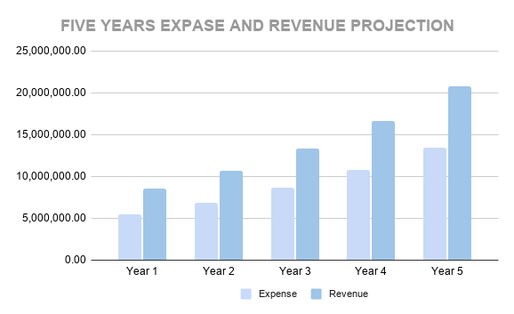

And the chart shows the expenses and the revenue for five years of our project. In the chart, it shows that the revenue is higher than the expense from the first year to year five. And in these year's the

Expense and the revenue is increasing day by day.

1. ***Net Cash Flow***

Net Cash Flow (NCF) is the difference between the expected revenue and expense. In expenses and revenue, we increased 25% extra in every year and then we calculated the net cash flow according to the following methods...For Example: In the 1st year…

(Revenue) 8,500,000.00 – (Expense) 5,501,500.00 = (Net Cash Flow) 2,998,500.00.

1. ***Payback Period***

Payback period actually tells about in which month/year or how many the year/time is needed to

get return of the invested amount. From our Business Calculations, we saw that if everything would go according to the plan we can get return our investment in between year 1 to year 2.

We calculated the payback Period according to the following methods.

(Investment – year 1)/Profit of the next year + Previous year

= (5,501,500.00 - 2,998,500.00) / 3,748,125.00 + 1

= 1.66 / 1 year 7 months

So, there might not be huge risk for the Company if it starts investing on the product right away.

1. ***Net Present Value (NPV)***

Net present value or the NVP is the difference between the present value of cash inflows and the present value of cash outflows over a period of time. And it's normally calculated based on NCF or net cash flow. Annex 4 shows our calculated NPV and it also shows that our NPV is positive as it increases day by day. Here we are assuming the cost of capital of 15% in both product lines, then we have been calculated the NPV. After a 5 years, our total NPV is 10008630.88. And it has a positive NPV which indicates that the projected earnings generated by both products and investment - in present amount - exceeds the anticipated costs which proves that an investment with a positive NPV will be profitable. Internal rate of return

(IRR): The internal rate of return is a metric used in financial analysis to estimate the profitability of potential investments. The Annex 4 shows our IRR, here 67% is the annual rate of growth in our product and it looks profitable.

1. ***IRR (Internal Rate of Return):***

The internal rate of return is a metric used in financial analysis to estimate the profitability of potential investments. The Annex 4 shows our IRR, here 67% is the annual rate of growth in our product and it looks profitable.

1. **ANNEXURES (Tables)**

**Annexure – 1: Detailed projections (pivoted product)**

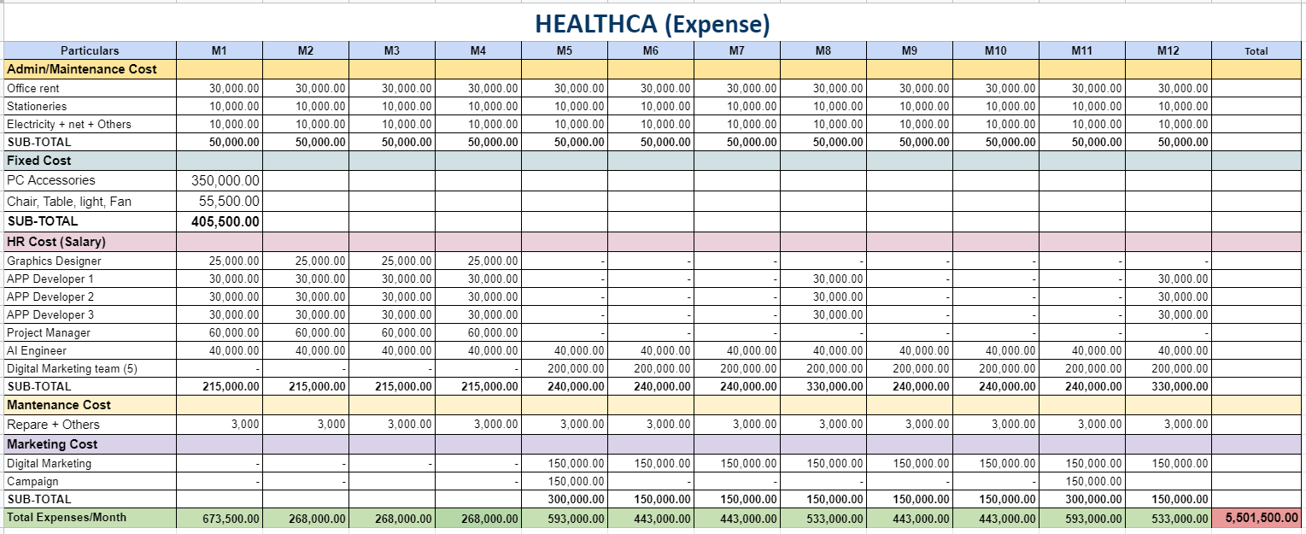

**Annexure – 2: NCF of existing product (collected from Company)**

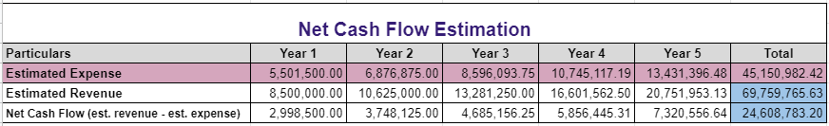

**Annexure – 3: NPV, IRR, Payback period of existing product** 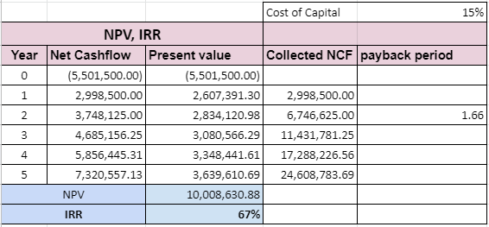

**Annexure – 4**

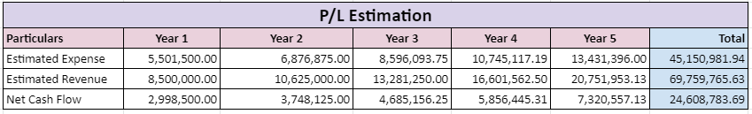

1. **Conclusion**

So in this project Paper we saw all the information in details of our product. The intention of the project is given, and what are the problems and solution. Then we did the SDLC where we showed our planning, analysis, our app's design, how we are going to launch etc. Most importantly we did all our budgeting and business analysis and this show how we are doing our project financially. But one question may arise that we will get back what we invest? Also if we fail, what can we do? So let’s have a look on it.

In the business analysis, we did a section called Payback period where we show when we will get back our investment. According to that section, if everything would go according to the plan we can get return our investment in between year 1 to year 2.

Also if our project wouldn't go with our plan or if we failed, for sure we are not going to stop our business. We can change our strategy by adding some features in the product. Also we can adopt a strategy called "Cost leadership strategy" where we will reduce the price of our products. Also we can hire a financial expert and many more things but for sure we are not going to stop our business if anything bad happens.

For building a successful startup, we have to do all the things carefully. We have to take care of our customers and users all the time and provide them a good service. After that, we have to ensure our investment. Then doing all these things we will be able to achieve our goals. So we hope we can achieve what we wanted to do and we will able to handle every situation.

1. **References**
2. Covid situation [(https://tbsnews.net/thoughts/covid-19-and-its-impact-bangladesh-economy69541)](https://tbsnews.net/thoughts/covid-19-and-its-impact-bangladesh-economy-69541)
3. Duties of Board of Directors ([https://www.extension.iastate.edu/agdm/wholefarm/html/c5-](https://www.extension.iastate.edu/agdm/wholefarm/html/c5-71.html)

[71.html](https://www.extension.iastate.edu/agdm/wholefarm/html/c5-71.html) [https://accountlearning.com/roles-duties-responsibilities-of-board-of-directors/)](https://accountlearning.com/roles-duties-responsibilities-of-board-of-directors/)

1. Board of Directors [(https://www.syndicateroom.com/learn/glossary/managementteam #:~:text=The%20management%20team%20is%20the,responsibility%20for%20key%20business%20f unctions.&text=The%20Management%20team%20are%20held%20accountable%20by%20the%20co mpanies%20board%20of%20directors)](https://www.syndicateroom.com/learn/glossary/managementteam#:~:text=The%20management%20team%20is%20the,responsibility%20for%20key%20business%20functions.&text=The%20Management%20team%20are%20held%20accountable%20by%20the%20companies%20board%20of%20directors)
2. Management Team ([https://schoolofherring.com/2015/04/08/the-purpose-of-a-managementteam/)](https://schoolofherring.com/2015/04/08/the-purpose-of-a-management-team/)
3. Pivoting ([https://smallbiztrends.com/2020/05/pivoting-business-strategy.html)](https://smallbiztrends.com/2020/05/pivoting-business-strategy.html) [6] Net Present Value [(https://www.investopedia.com/terms/n/npv.asp#:~:](https://www.investopedia.com/terms/n/npv.asp#:~: text=A%20positive%20net%20present%20value,result%20in%20a%20net%20loss)

[text=A%20positive%20net%20present%20value,result%20in%20a%20net%20loss.](https://www.investopedia.com/terms/n/npv.asp#:~: text=A%20positive%20net%20present%20value,result%20in%20a%20net%20loss))

1. IRR ([https://www.investopedia.com/terms/i/internal-rate-of-return-rule.asp)](https://www.investopedia.com/terms/i/internal-rate-of-return-rule.asp)
2. Cost Leadership Strategy ([https://www.consultantsreview.com/news/what-are-the-benefits-ofcost-leadership-strategy-nwid-1138.html)](https://www.consultantsreview.com/news/what-are-the-benefits-of-cost-leadership-strategy-nwid-1138.html)
3. Ways to manage risk during Covid ([https://www.lexology.com/library/detail.aspx?g=43b26766-](https://www.lexology.com/library/detail.aspx?g=43b26766-1842-4db8-b360-80e55d2090fe)

[1842-4db8-b360-80e55d2090fe)](https://www.lexology.com/library/detail.aspx?g=43b26766-1842-4db8-b360-80e55d2090fe)